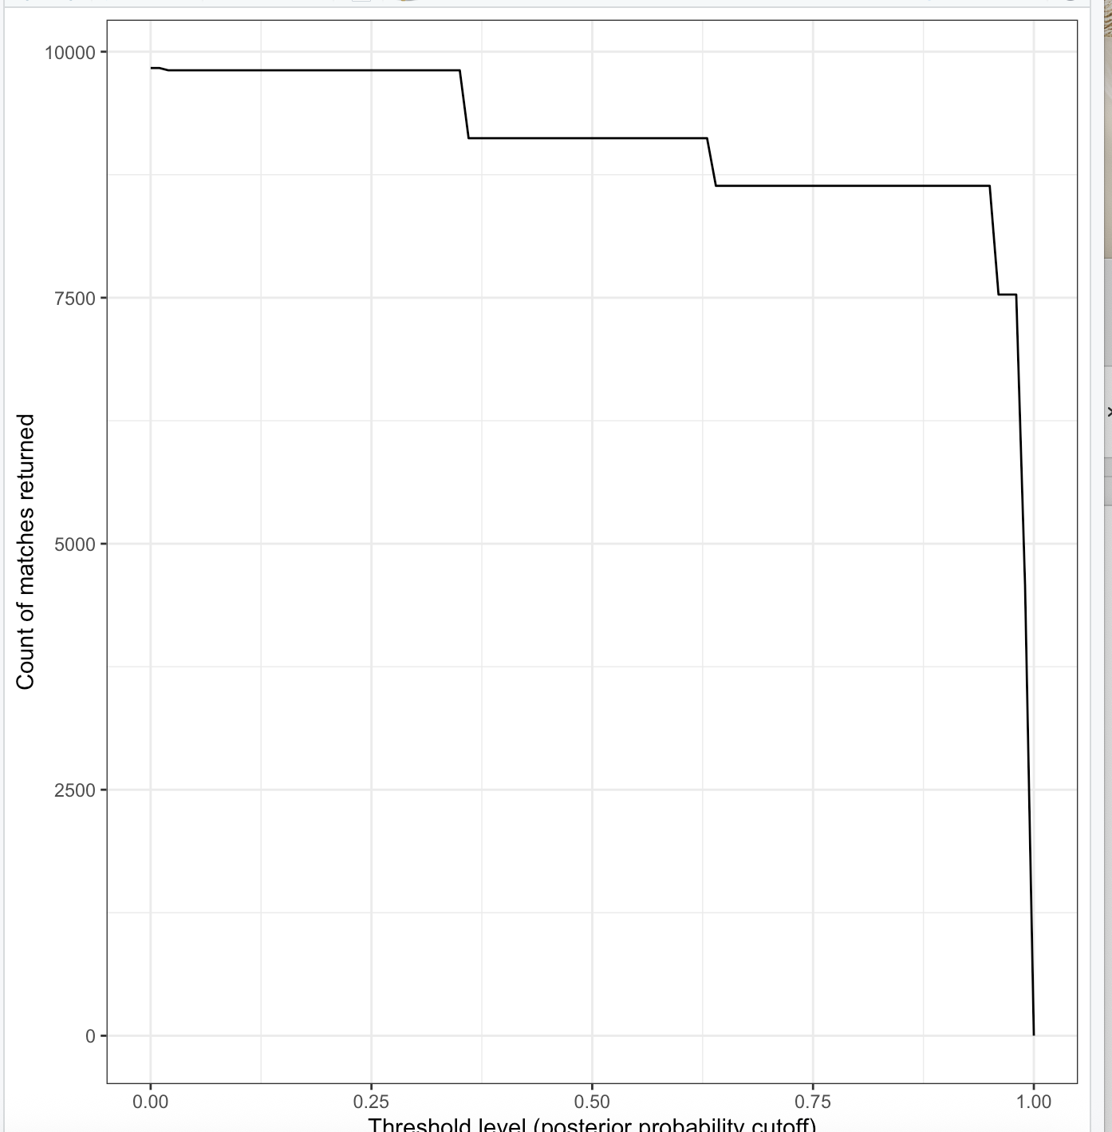
Conceptualization:
Deterministic match requires records to be exact string match on the identifiers with fast speed but misses imperfect matches.
False match Records incorrectly linked (different entities treated as same).
Miss match: Records not linked (same entity treated as different).
However, probabilistic matching can help on likelihood-based approach treating agreement on identifiers as evidence for true match.

Question 1
Numbers of Matches: 4588
Rate: =0.4588
Deterministic match requires exact agreement across all identifiers’ information. However, it is possible that the two datasets contain the same individuals, mismatches such as slightly different in birth year may prevent true matches from being identified. As a result, many valid matches will be missed.
Question 2
When the threshold decreases, the count of matches returned increased. When at low thresholds, weaker or uncertain pairs are accepted, so the match count stays very high, vice Vira. As the threshold increase, it required stronger certain pairs, and the match count stays very low. The role of threshold is to set up different probability for determination the bar for the pair entering in matching.
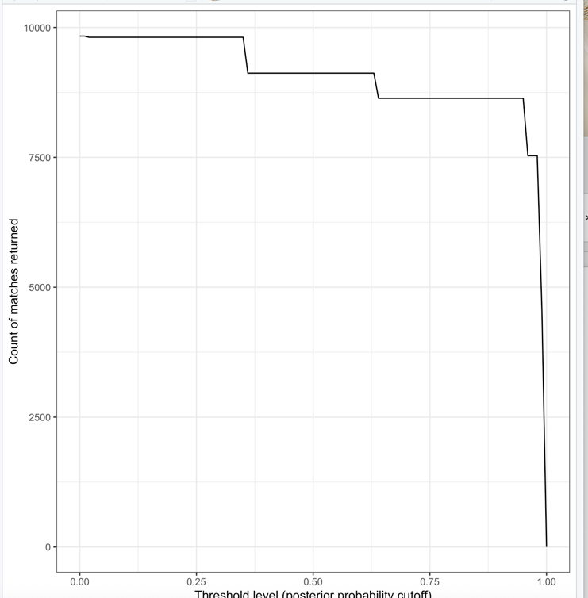

Question 3

A tibble: 4 × 5
threshold_bin mean_first mean_last mean_birth n
<chr> <dbl> <dbl> <dbl> <int>
1 0-0.1 3.13 3.91 1.52 23
2 0.3-0.4 1.49 1.73 1.46 690
3 0.6-0.7 2.94 3.41 0.0103 484
4 0.9-1 0.507 0.616 0.193 8637
Deterministic matching follows a strict requirement for the variables, so that the number of matches is not a lot, but probabilistic matching allows small errors there, which can increase the number of the matches.
With the threshold increases, the number of matching decreases, but the quality increases.
Two limitations for deterministic matching: 1) match requires records to be exact string match on the identifiers; 2) easily to miss the imperfect data
Two limitations for probabilistic matching: 1) Easily to occur the mismatching; 2) Relies on the assumption.
The results show a negative relationship between string distance and posterior probability.

